Дата: 10.11.2022 Клас: 7-А

Предмет: Англійська мова

Тема: Все про їжу.

Мета: формувати навички вживання нових лексичних одиниць з теми «Їжа»; вдосконалювати навички читання й мовлення з опорою на лексико-граматичні структури; розвивати мовну здогадку й мовленнєву реакцію учнів; виховувати зацікавленість у розширенні своїх знань.

Вчитель: Глуговська Л.Г.

**Хід уроку**

***1.Greeting***Good afternoon, dear children! I’m glad to see you. Are you ready to start our lesson? Let’s start.

***2. Warm up***

What diet is healthy and what is unhealthy in your opinion?

Complete the chart below with the items from the text (p. 64) and add some of your own.

Some ideas:

Meat, fish, eggs, beans, boiled potatoes and jacket potatoes, bread, rice, pasta, milk and dairy foods, fruit and vegetable juice, low-fat meat, fresh vegetables, frozen vegetables, cakes and biscuits, dried fruit, unsalted nuts, peanut and raisin mixes, unsalted popcorn, yoghurts, snacks such as crisps, salted nuts, onion rings and rice crackers, chocolates, ginger root, spinach, garlic and onions, chicken soup, plenty of grains, cereals, food and drinks that are high in fat and/or sugar, bread, hamburgers.

|  |  |
| --- | --- |
| Healthy diet | Unhealthy diet |
|  |  |

***3. Speaking***

Practise the vocabulary

|  |  |  |  |
| --- | --- | --- | --- |
| We should eat  We shouldn’t eat  We should drink  We shouldn’t drink | fresh fruit  dried fruit  fresh /frozen vegetables  meat  fish  dairy foods  unsalted nuts  salted nuts  many sweets  coffee  sparkling mineral  water  non-sparkling mineral water  fizzy sweet drinks  different snacks  bread  fresh juice  packed juice  cereals | because | they are a vital source of vitamins and minerals.  they are high in fibre content.  it’s a good source of protein.  they provide vitamins, minerals and complex carbohydrates.  they are low in fat.  it’s bad for our teeth.  we can get overweight.  it is good for your brain.  it is good for your spirits.  you can be at risk for high blood pressure. |

Example:

• We should eat fresh fruit and vegetables because they are a vital source of vitamins and minerals and they are high in fibre content.

• We should eat meat because it’s a good source of protein as well as fish, eggs and beans.

• We shouldn’t eat too many sweets because it’s bad for our teeth and we can get overweight.

• We should eat cereals because they provide vitamins, minerals and complex carbohydrates.

***4. Reading***

Do ex. 1 (b), p. 64.

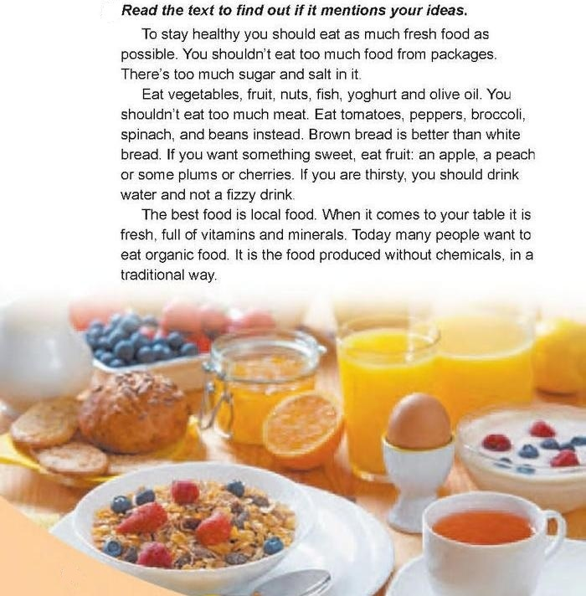

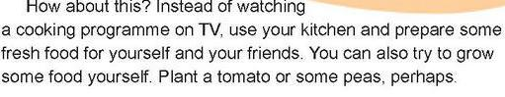

***5. Homework***

1. Опрацюйте конспект уроку;

2. Exercise 1 page 64-65 (усно).

**Надіслати виконане завдання у Вайбер/телеграм (0964124047) – Людмила Григорівна або на Human.**